CBH Ticket Breakdown

# Problem:

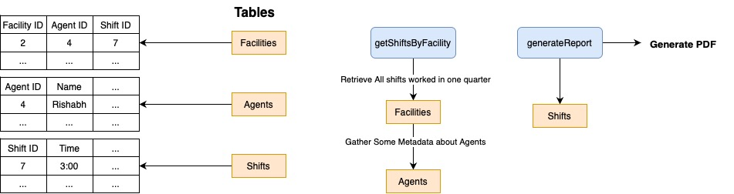

According to my understanding, There are 3 tables: Facilities, Agents and Shifts. The data that is stored in each of them is:

Facilities: Stores Information about a Facility, and the Agent and Shift that took place

Agents: Stores basic data about Agent

Shifts: Stores basic data about a Shift

# Solution:

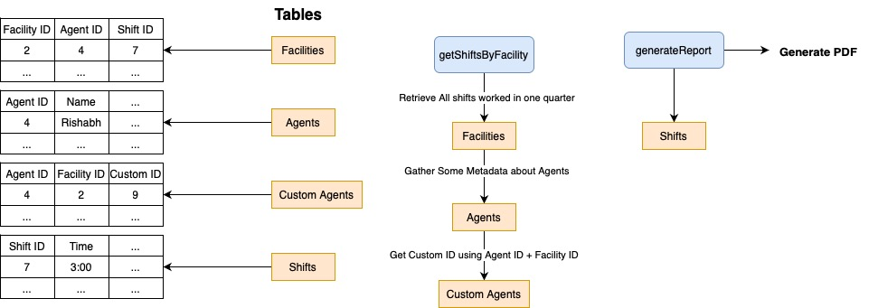

There are two solutions that we can implement. The one I went with is one where we create a new Table called Custom Agents. This will allow us to store the Custom ID of the Agent.

When calling the getShiftsByFacility function, we will make another call to this table and check if a custom ID is present. If yes, we will display the custom ID. If not, we will display the ID as before that we store in our database. The custom ID will be retrieved using Agent ID and Facility ID.

The other solution that we can implement is one of storing the custom ID along with the Agent table. But there are two drawbacks:

1. If there are Agents who work in multiple facilities and have different custom IDs in each of them, we would not be able to handle those cases
2. If there are Facilities which do not require a custom ID, we would be wasting space in our database by allocating unnecessary space for a field that is not required for all entries.